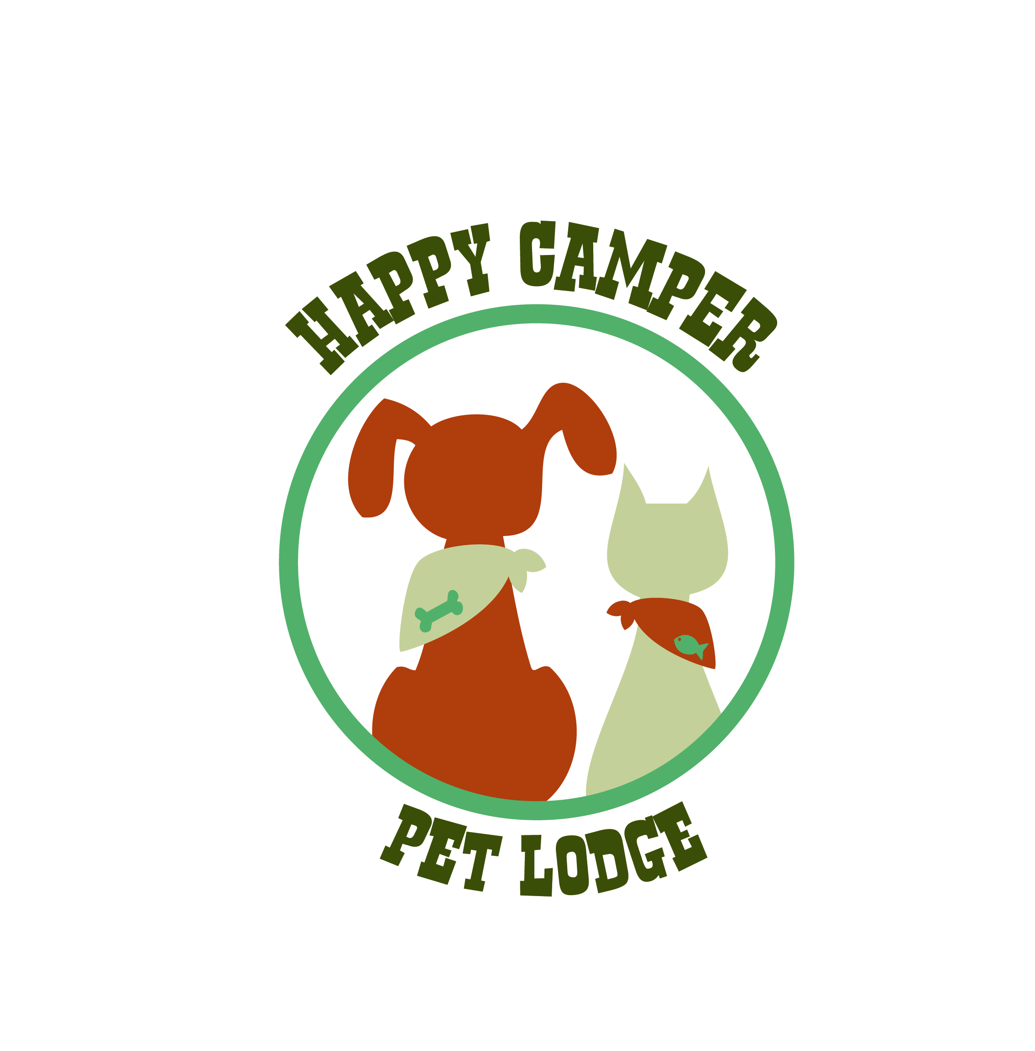
Happy Camper Pet Lodge
7300 Impala Drive
Richmond, Virginia 23228

Phone: 804-308-8218
Fax: 804-308-8218
www.HappyCamperPetLodge.com

Dear Client,
Thank you for choosing Happy Camper Pet Lodge! We are proud to offer fun, safe, and stimulating Daycamp and Boarding services for your pets. At our Daycamp, your dog will enjoy plenty of playtime with other dogs along with individual attention from our professional staff.
The following forms are required to register your pet. To enroll, simply complete and return the new client forms, waivers, and vaccine records to us. Feel free to drop off your application in person, mail it, email it or fax it to us.
Our team is committed to offering you and your pet the security of a home away from home and lots of exercise and play. Please don’t hesitate to call us at 804-308-8218 if you have any questions, or feel free to stop by to visit our facility; we are open Monday through Friday from 7:00 am to 7:00 pm, Saturday 9:00am to 6pm, and on Sundays for pick-up by appointment only. We look forward to meeting you and your pets.

Sincerely,
Preston Cottrell
Owner/Operator
www.HappyCamperPetLodge.com

